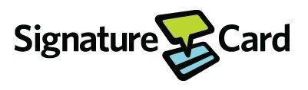

January 8th 2021

Angela Hayes
US Environmental Protection Agency
Life Scientist
1201 Elm St. Suite 500
Dallas, TX 75270

Angela:
Attached is the revised ACOC letter . We will sign once the letter is finalized by you and your department. Attached are the SOP’s described in section 41(A) of the ACOC.
- Signature Card LP has assessed all of its solid waste streams to determine the accurate waste codes;
- It has implemented the enclosed SOP; and
- It has accurately and adequately complied with its RCRA Section 3010 Notification.
I certify under penalty of law that this document and all of its attachments were prepared by me and under my direct supervision in accordance with a system designed to assure that qualified personnel properly gathered and evaluated the information submitted. Based on my inquiry of the person or persons who manage the system, or those directly responsible for gathering the information, the information submitted is, to the best of my knowledge and belief, true, accurate and complete. I am aware there are significant penalties for submitting false information including the possibility of fine and imprisonment for knowing violations.
The draft ACOC letter is attached to this email. Thank you for your assistance in resolving this matter.

Yours truly,

Willard Hunter

